FAX THIS COMPLETED QUESTIONNAIRE TO:

(321) 441-1559

THOROUGHLY complete this questionnaire. We know that it is a lot of writing, but it will help the doctor to better diagnose and provide you the appropriate care.

Your appointment is ___/___/ 2019 @ ____am / pm

OUR ADDRESS IS:

Downtown Location:
801 N. Orange Ave Ste 535, Orlando, FL 32801

PHONE: (407) 644-0101

Primary Care Physician (name and address):
Address:_________________________________________________________
Phone #___________________________Fax #__________________________

Personal Information:

Name__________________________________ Today’s Date______ Date of Birth ______
Age_____ Male_____ Female_____ Right handed_____ Left handed_____
Single____ Married____ Divorced____ Separated____ Widowed____
Highest Education___________ Occupation /Profession: _______________________
Accident Information Date of Injury: _________________
Type of Case: Automobile Fall Motorcycle Pedestrian Other___________________
Describe how the accident happened: __________________________________________________________________ __________________________________________________________________________________________________

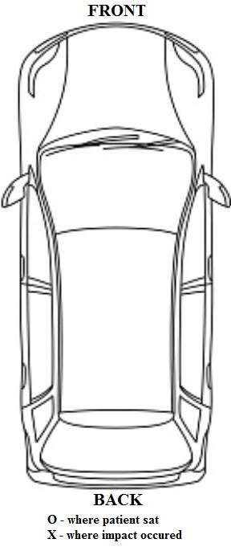
Were you the Driver? Yes or No Passenger? Yes or No

Were you sitting in the front seat or rear seat ?

Total Damage to you vehicle $ ____________

Year/Make/Model of you vehicle: ___________________________________

Was your vehicle? Moving or Stopped

Seat Belt: Yes or No

Did your airbags deploy? Yes or No

Where was you vehicle struck?
Rear-end or Passenger side or Driver side

During Impact: Did you brace with arms on?
Steering Wheel - Dashboard - Seat
Did you brace with legs on?
Floor - Brakes
Was your head? Straight or Turned Right or Turned Left

Did you strike any part of your body? Yes or No If yes against what? __________________________________ ____________________________________________________________________________________________

Was anyone in the vehicle with you? Yes or No If yes who? __________________________________
_____________________________________________________________

After collision: Did you experience Loss of consciousness? Yes or No If so, how many minutes? _____
Did you feel: Stunned Nervous Scared Dizzy Disoriented Lightheaded Confused
Immediate Symptoms:_________________________________________________________________________
Subsequent Symptoms:________________________________________________________________________

Were you evaluated by paramedics? Yes or No
Were you taken to hospital? Yes or No By ambulance? Yes or No
Hospital Treatment? Yes or No Did they do? X-rays - CT Scans – MRIs

2
Pain Assessment: Mark the area(s) where you feel your symptoms/pain

/////= Stabbing 0000= Tingling XXXX= Burning AAAA= Aching
TTTT= Throbbing SSSS=Shooting DDDD=Dull NNNN= Numb

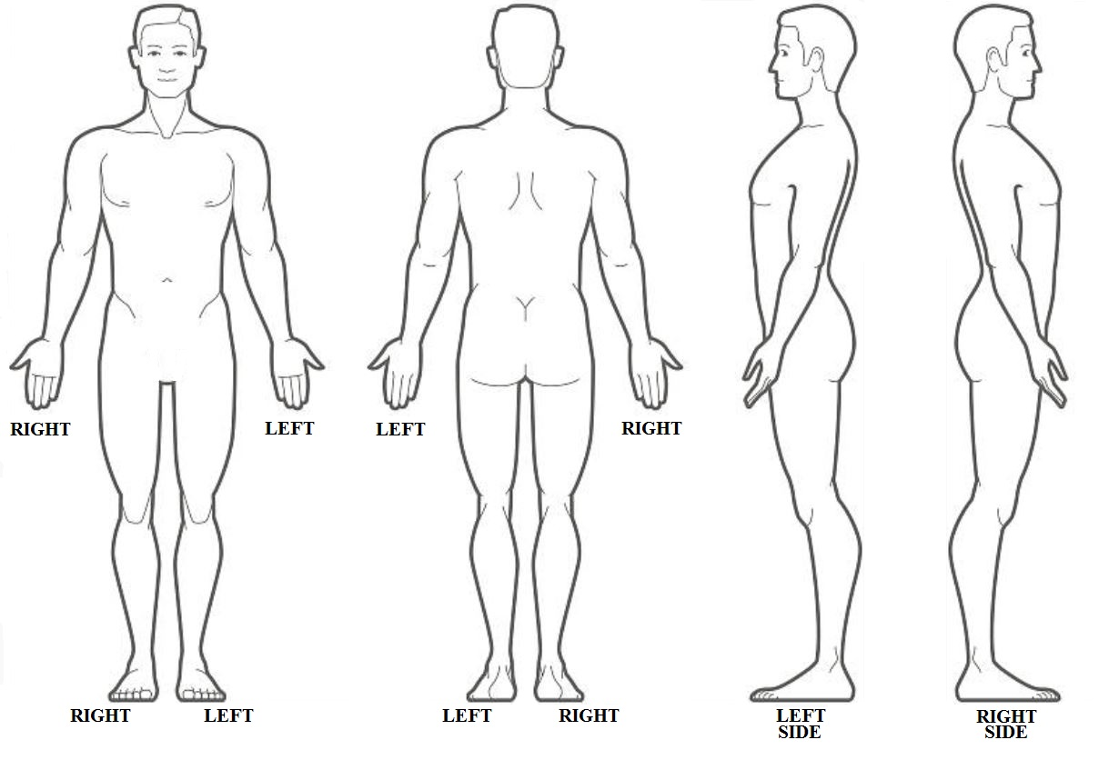

How often do your symptoms affect you?
Occasionally___(0-33% of the day) Frequently___(33-66%) Constant___(66-100%)

What time of the day your pain is most severe or frequent? (average)
Wake up by the pain ___, when arrive to work___, by noon___, mid-afternoon___, late in the evening__, when lying down to sleep___, Anytime___, I haven’t noticed___

After Hospital Treatment:
Dr. Name & Specialty:________________________________________________
Type of treatment: __________________________________________________
Other Treatment: ___________________________________________________

Previous treatment for this injury:_____________________________________________________________
_________________________________________________________________________________________
MRI, CT, X-rays for this injury:________________________________________________________________

3

Current Main / Primary Complaint
Location of your pain: ______________________________________________________
Describe pain: ___sharp, ___stabbing, ____dull, ____aching, ____burning, ___throbbing
Intensity: (from 1-10, if 10 is like cutting your arm off with no anesthesia) ____________
When do you experience the pain worst? ______________________________________
How frequently do you experience the pain? ____________________________________
What makes your pain worse? _______________________________________________
What makes your pain less? _________________________________________________
Anything else? ____________________________________________________________
________________________________________________________________________

Secondary Complaint
Location of your pain: ______________________________________________________
Describe pain: ___sharp, ___stabbing, ____dull, ____aching, ____burning, ___throbbing
Intensity: (from 1-10, if 10 is like cutting your arm off with no anesthesia) ____________
When do you experience the pain worst? ______________________________________
How frequently do you experience the pain? ____________________________________
What makes your pain worse? _______________________________________________
What makes your pain less? _________________________________________________
Anything else? ____________________________________________________________
________________________________________________________________________

Third Complaint
Location of your pain: ______________________________________________________
Describe pain: ___sharp, ___stabbing, ____dull, ____aching, ____burning, ___throbbing
Intensity: (from 1-10 , if 10 is like cutting your arm off with no anesthesia ____________
When do you experience the pain worst? ______________________________________
How frequently do you experience the pain? ____________________________________
What makes your pain worse? _______________________________________________
What makes your pain less? _________________________________________________
Anything else? ____________________________________________________________

4

Daily Functions:
Sleeping difficulties? No/Yes
- difficulty getting to sleep
- awakens from pain
- easily awakens (cannot sleep through the night)
- early awakening (before expected)
- awake tired (not rested)
Thirsty frequently? No__ Yes__ (how many glasses a day?___ )
Appetite greater than usual? No__ Yes__
Urinate frequently? No__ Yes__ Every __hours
Bowel movements: Daily__ every 2 days__ 3-5 days__ 6-7 days__

Current Medications: List ALL Medications, if there are more than you can list, bring a separate list with you.
Name of Medication Strength (mg) How Many Per Day? Were you taking Medication before your Accident?
________________________ ___________ ________________ Yes or No
________________________ ___________ ________________ Yes or No
________________________ ___________ ________________ Yes or No
________________________ ___________ ________________ Yes or No
________________________ ___________ ________________ Yes or No
________________________ ___________ ________________ Yes or No
________________________ ___________ ________________ Yes or No
________________________ ___________ ________________ Yes or No
________________________ ___________ ________________ Yes or No
________________________ ___________ ________________ Yes or No
________________________ ___________ ________________ Yes or No
________________________ ___________ ________________ Yes or No
________________________ ___________ ________________ Yes or No

Allergies: _______________________________________________________

Habits:
Important!!! These substances have serious adverse side effects if combined with medications, so help the physician to decide what medicine is safe for you!
Smoke tobacco: Yes or No. If yes, packs /day? _______, how many years? ______
Quit? (Yes or No) When? ______________
Drink Coffee / caffeine: No__/Yes__, how many cups/mugs/cans a day______
Drink Alcohol: No__/Yes__. How many glasses liquor or beers a day____ week____
Drug Use: No__/Yes___, Are you in a methadone program? No__/Yes__
Detail type of substance and frequency____________________________________

Legal Issues:
Is this work-related: Yes / No Date of injury: __________
Was your supervisor notified? Yes__ or No__
Is there any ongoing litigation? Yes__ or No__
Have you been awarded/ assessed an IMPAIRMENT or DISABILITY RATING for before? No / Yes, What was the rating percentage? _____

-5-

REVIEW OF SYSTEMS:

Please check ONLY those you had “BEFORE THIS INJURY”
____________________________________________________________________________________________________________

GENERAL:
□yes □no Unexplained changes in weight
□yes □no Fever
□yes □no Chills
□yes □no Night sweats
NEUROLOGICAL:
□yes □no Unusual change in voice
□yes □no Seizures
□yes □no Loss of consciousness
□yes □no Memory difficulties
□yes □no Disorientation
□yes □no Difficulty with speaking
□yes □no Difficulty with writing
□yes □no Difficulty with reading
□yes □no Dysphagia
□yes □no Double vision
□yes □no Loss of vision
□yes □no Tremors
□yes □no Difficulty walking
□yes □no Weakness
□yes □no Numbness
□yes □no Changes in sensation
□yes □no Tingling

HEAD:
□yes □no Headache
□yes □no History of head contusions
□yes □no Hearing
□yes □no Auditory problems
□yes □no Dizziness
□yes □no Ear buzzing
□yes □no Sinus (stuffy nose)
□yes □no Ear pain
□yes □no Dental problems
□yes □no Metal implants
□yes □no Bleeding gums

CARDIOLOGY/PULMONARY:
□yes □no Chest pain
□yes □no Palpitations
□yes □no Murmur
□yes □no Swollen feet legs worse at the end of the
day.
□yes □no Cough
□yes □no Wheezing
□yes □no Shortness of breath walking up one flight
Stairs.

GASTROINTESTINAL:
□yes □no Digestion problems
□yes □no Bloating
□yes □no Nausea
□yes □no Heartburn
□yes □no Vomiting
□yes □no Constipation
□yes □no Unexplained diarrhea
□yes □no Abdominal pain
□yes □no Sour mouth sensation after sleeping.

GENITAL/URINARY:
□yes □no Difficulty urinating
□yes □no Urge urinating
□yes □no Pain urinating
□yes □no Painful intercourse
□yes □no Vaginal secretions
□yes □no Bladder incontinence
□yes □no Kidney stones
□yes □no Kidney infections

MUSCULAR/SKELETAL:
□yes □no Diffuse muscle aching
□yes □no Fibromyalgia
□yes □no Legs or joint swelling
□yes □no Stiffness
□yes □no Painful foot sole or arch “first steps in the
morning”.

SKIN/HAIR:
□yes □no Changes in skin moles
□yes □no Non-healing ulcers
□yes □no Dry skin
□yes □no Itching
□yes □no Nail fungus

ENDOCRINE/HEMATOLOGICAL/IMMUNE:
□yes □no HIV positive
□yes □no Hepatitis
□yes □no Fainting
□yes □no Swollen armpit
□yes □no Swollen groin glands,
□yes □no Pale color
□yes □no Bleeding disorders
□yes □no Recurrent infection

-6-

PAST MEDICAL HISTORY - UNRELATED TO THIS INJURY !!! - (Only what was prior to this injury)
If diagnosed by physician check “X”. if probably, write a “P”
Specify when first started, in years (ie. 6 months)

Arthritis ________ Osteoarthritis ________
Neck pain ________ Heart attack ________
Back pain ________ Angina/ arrhythmias ________
Bleeding or blood clots ________ Hypertension /low pressure ________
Cholesterol ________ Osteoporosis ________
Diabetes ______Type I ( ) or Type II ( ) Osteopenia ________
Depression _______ Thyroid problems ________
Gastritis or peptic ulcer disease ______ HIV positive ________
Hepatitis ________ Syphilis ________
Deep vein thrombosis ________ Other_________________________

Is there significant stress at work? Yes__ No___
How does this make your pain worse?________________________________________

Any Food intolerance or allergy_____________________________________________

Imaging Studies (Before this Injury): _______________________________________________________________________
_______________________________________________________________________
_______________________________________________________________________
_______________________________________________________________________

Past Surgical History or prolonged hospitalizations you have had in the past:
Operation Month/Year Hospital/City Doctor
__________________ ______________ __________________ ___________________
__________________ ______________ __________________ ___________________
__________________ ______________ __________________ ___________________

Family Medical History
Father: alive? Yes__/No__ cause and age died _________________________________
If alive, age___ and medical problems________________________________________
Mother: alive? Yes__/No__, cause and age died________________________________
if alive, age: _____, diseases ________________________________________________
Number of Brothers________Number of Sisters________

-7-

Functional History:
Previous Level: check (‘x”) if you have a problem;
( ) Walking: independent___, use a cane___/brace____
( ) Climbing: upstairs independent?
( ) Driving: Independent?
( ) Transfers (get up, bed to chair, sitting to standing)
( ) Dressing oneself (shirt, pants, shoelaces)
( ) Eating/ drinking (cooking)
( ) Self care (urinating, defecating,) and personal
( ) Hygiene (bathing, brushing, combing, etc)

Social History:
I live in a House /Apartment / Other_________
How many steps/stairs to your room?________
Do you live alone? Yes__ / No__, with whom? _________________________________ If you have a home attendant, #hours/day_____/_____

Educational Background: (circle you answer)
What was your highest level of Schooling?
High school, Technical school, Associates, College
Did you have any learning disabilities prior to the accident? Yes / No
Were you ever held or left back a grade in school? Yes / No
Have you had any history of ADHD prior to the accident? Yes / No
Did you have any need for Special Education Classes prior to the accident?? Yes / No
Did you ever require tutoring prior to the accident? Yes / No
On average what were your grades? A’s, B’s, C’s, D’s, F’s

Functional Work Demands:
Current occupation____________________________________________________
Primary activities you do at work: Sitting ( ), standing ( ), kneeling ( ), bending forward ( ) bending backward ( ) rotating the trunk ( ) squatting ( ) reaching ( )
What is the maximum weight you can tolerate lifting without provoking pain? ______lbs
How many hours spend sitting? _____ How many hours using the computer? _____
How many hours standing? ________

Recreational History:
Practice Sports or exercise? No__ /Yes__. If yes, how many times a week?____________ What kind of sports? ______________________________________________________

I enjoy (movies/ theater / listen music /dancing, racing, etc)_______________________

-8-

________________________________________________________________________
*Complete Boxes Below ONLY if you have had any Prior Motor Vehicle Collisions
with Injuries?
Date of PRIOR MVA: ___________Type of Collision: □ Head-on
□ Rear-ended
□ Side-impact
Driver’s side impact
Passenger side impact
Area of Body Injured:
1) _________________________________________3) ________________________________________
2) _________________________________________4) ________________________________________

Property Damage Amount: $__________.00

Last Treatment Date:________________________

Date of other PRIOR MVA: ___________Type of Collision: □ Head-on
□ Rear-ended
□ Side-impact (T-Bone):
Driver’s side impact
Passenger side impact
Area of Body Injured:
1) _________________________________________3) ________________________________________
2) _________________________________________4) ________________________________________

Property Damage Amount:$__________.00

Last Treatment Date:________________________

-9-

BECK Inventory Questionnaire:
This group of questions will help your doctor understand how pain has changed your outlook on life. In each group, pick out one statement that best describes how you have been feeling the past week, including today:

1. 0. I do not feel sad 2. 0. I have not lost interest in other people
1. I feel sad sometimes 1. I am less interested in other people than
- I am sad all of the time I used to be
- I am so sad/unhappy that I can’t stand it 2. I have lost most of my interest in other
- I have lost all interest in other people people

3. 0. I am not particularly discouraged about 4. 0. I make decisions about as well as I ever
the future could
- I feel discouraged about the future 1. I put off making decisions more than I
- I feel I have nothing to look forward to used to
- I feel the future is hopeless and things 2. I have greater difficulty in making
cannot improve decisions than before
3 I can’t make decisions at all anymore

5. 0. I do not feel like a failure 6. 0. I don’t feel I look any worse than I used
- I feel I have failed more than the average to
person 1. I am worried that I am looking old or
- As I look back on my life, all I see is a lot unattractive
of failure 2. I feel that there are permanent changes in
- I feel I am a complete failure as a person my appearance
3 I believe that I look ugly

7. 0. I get as much satisfaction out of things as 8. 0. I can work about as well as before
I used to 1. It takes an extra effort to get started at
- I don’t enjoy things like I used to doing something
- I don’t get real satisfaction out of 2. I have to push myself very hard to do
anything anymore anything
- I am dissatisfied or bored with 3. I can’t do any work at all
Everything

9. 0. I don’t feel particularly guilty 10. 0. I can sleep as well as usual
- I feel guilty a good part of the time 1. I don’t sleep as well as I used to
- I feel quite guilty most of the time 2. I wake up 1-2 hours earlier than usual
- I feel guilty all of the time and find it hard to get back to sleep
3 I wake up several hours earlier than I
used to & cannot get back to sleep

11. 0. I don’t feel that I am being punished 12. 0. I don’t get more tired than usual
1. I feel I may be being punished 1. I get tired more easily than I used to
2. I expect to be punished 2. I get tired from doing anything
3. I feel I am being punished 3. I am too tired to do anything

13. 0. I don’t feel disappointed in myself 14. 0. I don’t feel that I am worse than
- I am disappointed in myself Anyone else
- I am disgusted with myself 1. I am critical of myself for my
- I hate myself weaknesses and mistakes
2. I blame myself all of the time for my
faults
3. I blame myself for everything bad that
Happens
-10-

BECK Inventory Questionnaire (Continued):

15. 0. I am not more irritated now than I ever 16. 0. I haven’t lost much weight, if any, lately
- I get annoyed to irritated more easily 1. I have lost more than 5 pounds
than I used to 2. I have lost more than 10 pounds
- I feel irritated all of the time now 3. I have lost more than 15 pounds
- I don’t get irritated at all by things that
used to irritate me

17. 0. I don’t have thoughts of killing myself 18. 0. I am more worried about my health than
1. I have thoughts of killing myself, but I usual
would not carry them out 1. I am worried about my physical problems
2. I would like to kill myself such as aches and pains, upset stomach,
3. I would kill myself if I had the chance constipation.
2. I am very worried about my physical
Problems and it’s hard to think of much else
3. I am so worried about my physical
problems that I can’t think of much else

19. 0. I don’t cry anymore than usual 20. 0. I have not noticed any recent change in my
1. I cry more than I used to interest in sex
- I cry all of the time now 1. I am less interested in sex
- I used to be able to cry, but now I can’t 2. I am much less interested in sex
cry even though I want to 3. I have lost interest in sex completely

21. 0. My appetite is not worse than usual
- My appetite is not as good as it used
to be
- My appetite is much worse now
- I have no appetite at all

OFFICE USE ONLY
11-16 ml __________________
17-26 MO__________________
>26s __________________

11
Neurobehavioral Symptom Inventory (NSI)

Name: ____________________________________________________________Date: ___________________________
Please rate the following symptoms to how much they have disturbed you IN THE LAST TWO WEEKS. Rate each symptom from 0 to 4, as based on the following definitions.
0 = None – Rarely if ever present; not a problem at all.
1 = Mild – Occasionally present, but it does not disrupt my activities; I can usually continue what I’m doing and it
does not concern me.
2= Moderate – Often present, occasionally disrupts my activities; I can usually continue what I’m doing with some
effort; I feel somewhat concerned.
3= Severe – Frequently present and disrupts activities; I can only do things that are fairly simple or take little effort;
I feel I need help.
4= Very Severe- Almost always present and I have been unable to perform at work, school or home due to this problem;
I probably cannot function without help.

Number | Symptom Description
1 | Feeling dizzy | 0 1 2 3 4
2 | Loss of balance | 0 1 2 3 4
3 | Poor coordination, clumsy | 0 1 2 3 4
Vestibular Total:
Number | Symptom Description
4 | Headaches | 0 1 2 3 4
5 | Nausea | 0 1 2 3 4
6 | Vision problems, blurring, trouble seeing | 0 1 2 3 4
7 | Sensitivity to light | 0 1 2 3 4
8 | Hearing difficulty | 0 1 2 3 4
9 | Sensitivity to noise | 0 1 2 3 4
10 | Numbness or tingling on parts of my body | 0 1 2 3 4
11 | Change in taste and/or smell | 0 1 2 3 4
Somatosensory Total:
Number | Symptom Description
12 | Loss of appetite or increased appetite | 0 1 2 3 4
13 | Poor concentration, can’t pay attention, easily distracted | 0 1 2 3 4
14 | Forgetfulness, can’t remember things | 0 1 2 3 4
15 | Difficulty making decisions | 0 1 2 3 4
16 | Slowed thinking, difficulty getting organized, can’t find things | 0 1 2 3 4
Cognitive Total:
Number | Symptom Description
17 | Fatigue, loss of energy, getting tired easily | 0 1 2 3 4
18 | Difficulty falling asleep or staying asleep | 0 1 2 3 4
19 | Feeling anxious or tense | 0 1 2 3 4
20 | Feeling depressed or sad | 0 1 2 3 4
21 | Irritability, easily annoyed | 0 1 2 3 4
22 | Poor frustration tolerance, feeling easily overwhelmed by things | 0 1 2 3 4
Affective Total:
-12- TOTAL: _____________

Directions to Downtown location:
When traveling west on I-4:
Exit Ivanhoe Blvd, at the bottom of the offramp turn left (east) onto Lakeview. Stay in the far right lane on Lakeview as it turns to the right, it will become Orange Avenue. The Sixth Street on your left will be Park Lake, Turn Left. The second driveway on your left is the driveway to the parking garage for the 801 building. Drive up to the 4th floor and turn right at the elevator, our reserved spots are straight ahead marked MD Diagnostics.
When traveling east on I-4:
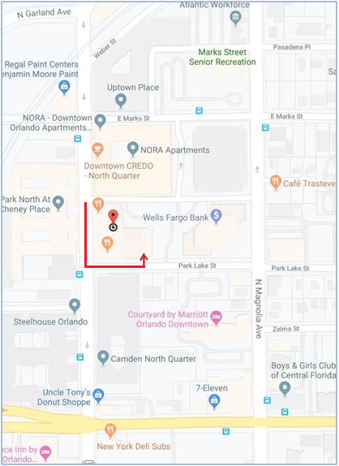
Exit the Amelia street exit. Stay in the middle lane and continue straight onto Garland Avenue. After you pass through Colonial, continue straight for approx. 2 blocks. Turn right onto Marks street and another right on Orange Ave. Merge to the far left lane, 2 streets on your left will be Park Lake, Turn Left (See red arrow on map below). The second driveway on your left is the driveway to the parking garage for the 801 building. Drive up to the 4th floor and turn right at the elevator, our reserved spots are straight ahead marked MD Diagnostics.

13

