THOROUGHLY complete this questionnaire. We know that it is a lot of writing, but it will help
the doctor to better diagnose and provide you the appropriate care.

FAX THIS COMPLETED QUESTIONNAIRE TO:

(321) 441-1559

(If you cannot print/fax/scan/email this questionnaire back to us in advance,
please arrange to arrive 15 minutes earlier than your appointment date/time to complete the form).

Arrive for your appointment at __am / pm on __/__/ 2019

Please bring questionnaire with you in case fax line is down

OUR ADDRESS IS: 801 N. Orange Avenue, Suite 535, Orlando, FL 32801
PHONE: (407) 644-0101

PERSONAL INFORMATION

Name_______________________________ Today’s Date________ Date of Birth ________
Circle one below
Single | Y | N
Married | Y | N
Divorced | Y | N
Widowed | Y | N
Age______ Right-handed Left-handed Sex: Male Female
Highest Education___________ Occupation /Profession: __________________________

CURRENT MEDICAL COMPLAINTS

Main Complaint: Date symptom began and is it stable, on/off, getting worse/better.
____________________________________________________________________________________________________________
____________________________________________________________________________________________________________
____________________________________________________________________________________________________________
Secondary Complaints: ________________________________________________________________________________________
____________________________________________________________________________________________________________
____________________________________________________________________________________________________________

Pain Assessment: Mark the area(s) where you feel your symptoms.

///////= Stabbing pain; 0000= Tingling; XXXX= Burning; AAAA= Aching; TTTT= Throbbing; SSSS=Shooting; DDDD=Dull; NNNN= Numb.

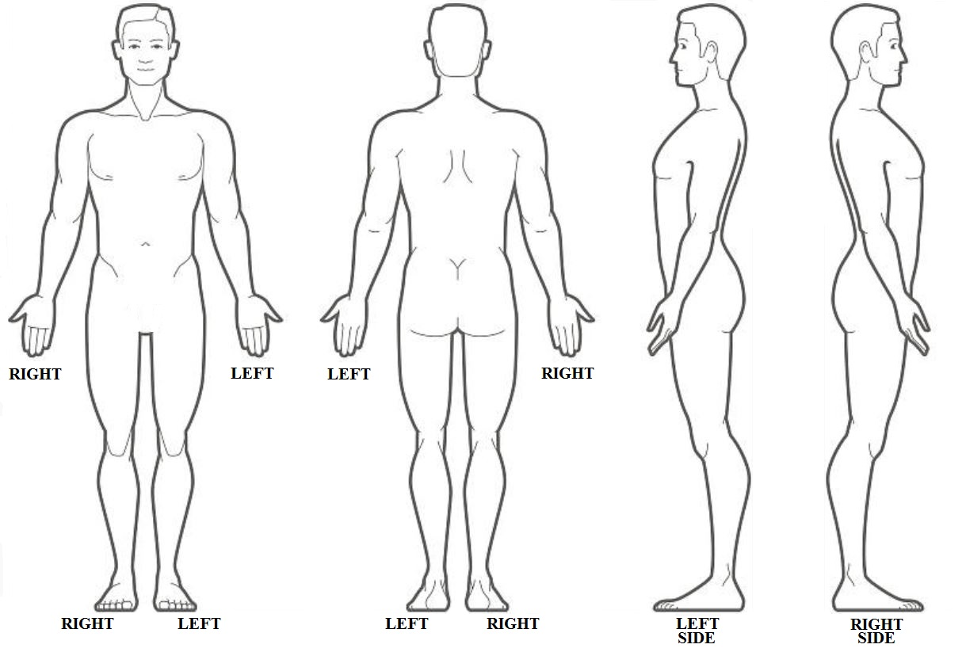

CLINICAL PATIENT INFORMATION SHEET
Print CLEARLY and leave no blank spaces

Patient Do you smoke? ___yes ___no Packs/day =____
Name: _________________________________ Date you stopped smoking ___/___/___
Name of Primary Care/ Family Physician (if any): Do you drink? ___yes ___no Drinks/day =
Do you use drugs? ___yes ___no
_______________________________________ Do you use ILLICIT drugs? ___yes ___no
If yes, date stopped ___/___/___
Phone #:________________________________
List ALL medications you are taking at this time:
COMPLAINT:_____________________________ NAME / STRENGTH & NUMBER

_______________________________________ ________________________________________________
_______________________________________ ________________________________________________

If seen in an emergency room, name of hospital: ________________________________________________

_______________________________________ ________________________________________________

Have you been treated by another doctor? ________________________________________________
______Yes ______No
________________________________________________
Name of other doctor: ____________________
________________________________________________
List all surgeries you have had:

_________________________________________ List any medications you are allergic to:

_________________________________________ _________________________________________

_________________________________________ _______ __________________________________

Have you had past history of the following: _______ __________________________________
____Yes ____No Glaucoma Has any member of your family had a history of the
____Yes ____No Diabetes following:
____Yes ____No Thyroid Disease
____Yes ____No High blood pressure ____Yes ____No Glaucoma
____Yes ____No Lung Disease ____Yes ____No Diabetes
____Yes ____No Heart disease ____Yes ____No Thyroid Disease
____Yes ____No Stomach ulcer ____Yes ____No High blood pressure
____Yes ____No Recent infections ____Yes ____No Lung disease
____Yes ____No Cancer (type) ______________ ____Yes ____No Heart disease
____Yes ____No HIV Positive (AIDS) ____Yes ____No Stomach ulcer
____Yes ____No Hepatitis B ____Yes ____No Recent infections
____Yes ____No Bleeding/blood clots ____Yes ____No Cancer (type) _________
____Yes ____No Neck/back pain ____Yes ____No HIV Positive (AIDS)
____Yes ____No Syphilis ____Yes ____No Hepatitis B
____Yes ____No Arthritis ____Yes ____No Bleeding/blood clots
____Yes ____No Neck/back pain
Any other medical problems? _______________________ ____Yes ____No Syphilis
____Yes ____No Arthritis
___________________________________________ ____

How often do your symptoms affect you?
Occasionally___(0-33% of the day) Frequently___(33-66%) Constant___(66-100%)

What time of the day your pain is most severe or frequent? (average)
Wake up by the pain ___, when arrive to work___, by noon___, mid-afternoon___, late in the evening__, when lying down to sleep___, Anytime___, I haven’t noticed___.

Discomfort Rating:
On a scale of 0 to 10 (0 being no discomfort, # 5 if discomfort starts interfering with activities
and 10 being the worst discomfort you can imagine and you would go to ER):

What is your Highest / Worst Level of discomfort? | 0 | 1 | 2 | 3 | 4 | 5 | 6 | 7 | 8 | 9 | 10
What is your Lowest Level of discomfort? | 0 | 1 | 2 | 3 | 4 | 5 | 6 | 7 | 8 | 9 | 10
What is your Usual / Average Level of discomfort? | 0 | 1 | 2 | 3 | 4 | 5 | 6 | 7 | 8 | 9 | 10
What is your Current Level of discomfort? | 0 | 1 | 2 | 3 | 4 | 5 | 6 | 7 | 8 | 9 | 10

Previous treatment for current complaints
________________________________________________________________________

________________________________________________________________________

Sleeping difficulties from pain (partly or mainly)? No/Yes

________________________________________________________________________

REVIEW OF SYSTEMS:
Please CHECK each that applies to you.
__________________________________________________________________________________________

GENERAL:
□yes □no Unexplained changes in weight
□yes □no Fever
□yes □no Chills
□yes □no Night sweats
NEUROLOGICAL:
□yes □no Unusual change in voice
□yes □no Seizures
□yes □no Loss of consciousness
□yes □no Memory difficulties
□yes □no Disorientation
□yes □no Difficulty with speaking
□yes □no Difficulty with writing
□yes □no Difficulty with reading
□yes □no Dysphagia
□yes □no Double vision
□yes □no Loss of vision
□yes □no Tremors
□yes □no Difficulty walking
□yes □no Weakness
□yes □no Numbness
□yes □no Changes in sensation
□yes □no Tingling
□yes □no Bleeding gums
HEAD:
□yes □no Headache
□yes □no History of head contusions
□yes □no Hearing
□yes □no Auditory problems
□yes □no Dizziness
□yes □no Ear buzzing
□yes □no Sinus (stuffy nose)
□yes □no Ear pain
□yes □no Dental problems
□yes □no Metal implants
CARDIOLOGY/PULMONARY:
□yes □no Chest pain
□yes □no Palpitations
□yes □no Murmur
□yes □no Swollen feet legs worse at the end of the
day.
□yes □no Cough
□yes □no Wheezing
□yes □no Shortness of breath walking up one-flight
GASTROINTESTINAL:
□yes □no Digestion problems
□yes □no Bloating
□yes □no Nausea
□yes □no Heartburns
□yes □no Vomiting
□yes □no Constipation
□yes □no Unexplained diarrheas
□yes □no Abdominal pain
□yes □no Sour mouth sensation after sleeping.
GENITAL/URINARY:
□yes □no Difficulty urinating
□yes □no Urge urinating
□yes □no Pain urinating
□yes □no Painful intercourse
□yes □no Vaginal secretions
□yes □no Bladder incontinence
□yes □no Kidney stones
□yes □no Kidney infections
MUSCULAR/SKELETAL:
□yes □no Diffuse muscle aching
□yes □no Fibromyalgia
□yes □no Legs or joint swelling
□yes □no Stiffness
□yes □no Painful foot sole or arch “first steps in the
morning”.
SKIN/HAIR:
□yes □no Changes in skin moles
□yes □no Non-healing ulcers
□yes □no Dry skin
□yes □no Itching
□yes □no Nail fungus
ENDOCRINE/HEMATOLOGICAL/
IMMUNE:
□yes □no HIV positive
□yes □no Hepatitis
□yes □no Fainting
□yes □no Swollen armpit
□yes □no Swollen groin glands,
□yes □no Pale color
□yes □no Bleeding disorders
□yes □no Recurrent infections

Stairs.

Is there significant stress at work? Yes__ No___, at home? Y___ No___ Do you feel this stress makes your pain worse Yes___ No____

Any Food intolerance or allergy______________________________________________________________________________

Upon agreement between the Patient (and/or Responsible Person) and the treating Physician, I hereby authorize the Physicians of M.D. Diagnostic Specialists, LLC and /or Rolando Amadeo, MD; to administer such Medical Care as may be deemed advisable in diagnosis and treatment of the Patient.

Patient Signature: __________________________________________________________________ Date: _________________________________
(Or legal guardian, if minor or patient incapacity)

